Title: Economic Environmental Optimization in Multiple Renewable Energy Sources with Demand Response based on Multi-Objective Optimization Algorithm
Journal: International Journal of Renewable Energy Development

Reviewer A:

The manuscript presents a comprehensive multi-objective optimization (MOO) framework integrating PV, wind, BESS, EV, DR, and Hydrogen Turbines (HT). While the topic is relevant and the technical approach is sound, several critical areas require substantial improvement before the paper can be considered for publication.

Reviewer Comments and Arguments
1. Technical Clarification and Mathematical Rigor
Comment:
• Battery Constraints: Equation (4) describes the State of Charge (SOC). However, the manuscript must clarify the physical meaning of E{us} and E_{usa} used in the denominator. Are these total capacity or usable capacity? Consistency in notation is required.
Response:
Thank you for pointing out the ambiguity in the SOC notation. In Eq. (4), $E_{us}$ was a typing mistake; we corrected it to $E_{usa}$ to ensure consistent notation. We also clarified that $E_{usa}$ just represents the usable battery energy capacity (kWh) (not capacity) used in Eq. (4)
Action:
$$SOC(i+1)=SOC(i)+\frac{P_{ch}(i)t_{ch}(i)η_{ch}}{E_{\text{us}\text{a}}}-\frac{P_{\text{dis}}(i)t_{\text{dis}}(i)}{E_{\text{usa}}η_{\text{dis}}}-\frac{P_{\text{sf }-\text{ dis }}(i)}{E_{\text{usa}}}$$

$E_{usa}$ signifies the usable battery energy capacity over a whole cycle (kWh),

Comment:
• Time Step Definition: There is a discrepancy in time indices. Equations (6) and (7) use indices but the study is described as a "24-hour case study" with "hourly demand". If the simulation is hourly, these indices should not exceed 24. Please clarify if the time step is minutes or hours.
Response:
Thank you for your careful observation. We deeply appreciate this comment, as it helped us improve the clarity and reproducibility of the formulation. The section and the sentences based on this comment has been clarified.
Action:
To ensure that the charging and discharging of the battery only takes place during the time period that has been stated in the proposed model, two binary availability indicators are introduced, let $t∈\{1,…,24\}$ denote the hourly time slot with $Δt=1h$. The charging and discharging availability indicators are defined as:
$$t_{ch}(i)=\left\{\begin{matrix}1, & \text{if }9≤i≤16 \\ 0, & \text{otherwise}\end{matrix}\right.$$ | (6)
$$t_{dis}(i)=\left\{\begin{matrix}1, & \text{if }17≤i≤22 \\ 0, & \text{otherwise}\end{matrix}\right.$$ | (7)
where $t_{ch}(t)∈\{0,1\}$ and $t_{dis}(t)∈\{0,1\}$ signifies whether charging and discharging is permitted at hour $t$ respectively. So, charging is allowed during hours 9–6 and discharging during hours 17–22 of the 24-hour scheduling horizon.

Comment:
• Hydrogen Turbine Model: The model for the HT (Eq. 18) depends on the hydrogen consumption rate m{H2,t}. The paper needs to explicitly describe the source of this hydrogen (e.g., an electrolyzer model) to justify the assumption of "abundant renewable energy" availability for hydrogen production.
Response:
We sincerely appreciate the reviewer’s careful observation. In the original draft, the HT subsection was mistakenly described using a hydrogen-fueled turbine formulation (i.e., hydrogen consumption rate $m_{H2,t}$and hydrogen availability), which would indeed require an explicit hydrogen production/supply model (e.g., electrolyzer and storage scheduling) to be fully reproducible. To eliminate this inconsistency and avoid relying on an unmodeled “abundant renewable energy” assumption, the manuscript has been revised to correctly model HT as a hydro turbine (hydropower) unit. Accordingly, Eq. (18) and the related constraints have been rewritten by remove the all hydrogen-dependent variables and we have them with a hydro turbine representation based on rated power limits and an available hydro-resource (energy/water-budget) constraint over the scheduling horizon. In addition, all associated descriptions in the Abstract, Innovation, and Methodology were updated consistently from “hydrogen turbine” to “hydro turbine,” and the emissions objective was revised so that operational emissions are only attributed to grid imports (hydro operational emissions are treated as negligible, consistent with other renewable resources). These corrections ensure internal consistency, model clarity, and reproducibility without introducing an electrolyzer sub-model that is outside the scope of the day-ahead EMS problem considered in this study. Special thanks again for this highly constructive comment, which reflects the reviewer’s deep expertise in hydrogen-integrated energy system modeling and highlights an important reproducibility requirement.
Action:
The HT is modeled as a controllable hydropower unit that provides scheduled generation within technical constraints. Hydro operation is represented using a capacity bound and an equivalent available hydro-energy (water-budget) constraint to prevent over-dispatch over the 24-h horizon. The HT output power at time $t$ is limited by Eq. (18) as follows (Chan et al., 2025):
$$0≤P_{t}^{HT}≤P_{ }^{HT(max)}​$$ | (18)
Hydro generation over the horizon is limited by the available hydro energy as follows in Eq. (19):
$$\sum_{t}{ }P_{t}^{HT}Δt≤E_{HT}^{avail}$$ | (19)
where $E_{HT}^{avail}$(kWh) signifies the available hydro energy over the scheduling horizon. This energy can be related to the available water resource through an equivalent conversion.
$$E_{HT}^{avail}=κ_{HT}w_{avail}$$ | (20)
where $W_{avail}$ represents the usable water volume over the horizon and $κ_{HT}$ is an equivalent conversion coefficient that captures effective head and turbine-generator efficiency. This formulation ensures feasible HT scheduling without requiring a detailed hydraulic model.

2. Results and Discussion
Comment:
• Pareto Front Analysis: Figures 12 and 13 show the Pareto fronts. The authors claim that DR shifts the cost range to $6,300–$11,1509. However, the "without DR" scenario is cited as having a lower bound of $5,50010. This implies that the minimum possible cost increased with DR, which contradicts the claim of "cost savings. Provide a deeper analysis of why the lower bound of the Pareto front shifted upward if DR is meant to provide flexibility.
Response:
The reviewer's observation is acknowledged. The reported "cost savings" are not contradicted by the apparent upward shift of the minimum cost point (≈$5,500 without DR vs. ≈$6,300 with DR). The savings statement refers to the representative operating point selected from the Pareto set (the highlighted "Best Solution"), rather than the single extreme endpoint of the Pareto front. In multi-objective optimization, the minimum-cost endpoint is often an extreme solution that can be attained by sacrificing a competing objective (in this case, emissions), therefore it is not always an appropriate dispatch option.
Furthermore, in the DR-enabled example, the feasible set and cost composition vary because DR adds new limitations (e.g., flexibility limits and energy/comfort preservation) and may incorporate compensation/incentive-related cost components in the overall objective. These characteristics may slightly increase the absolute minimum attainable cost, even while DR improves the trade-off region and produces better compromise solutions. Importantly, when compared to the chosen compromise solution (used for operational discussion), DR provides a lower-cost and lower-emission operating point: the "Best Solution" decreases from C = 9847.1 (without DR) to C = 8074.6 (with DR), while emissions decrease from E = 15661.7 to E = 12842.6, as shown in Figs 12-13. The text has been changed to state that the performance comparison is based on the chosen compromise point, whereas the extreme endpoints primarily reflect boundary trade-offs and are sensitive to discrete Pareto sampling.
Action:
The representative best solution from the Pareto set is used in the comparative analysis. Fig. 12 and Fig. 13 shows that DR improves the practical cost-emission trade-off. This is notable because DR increases performance by lowering both objectives simultaneously (without DR, C = 9847.1 and E = 15661.7; with DR, C = 8074.6 and E = 12842.6).
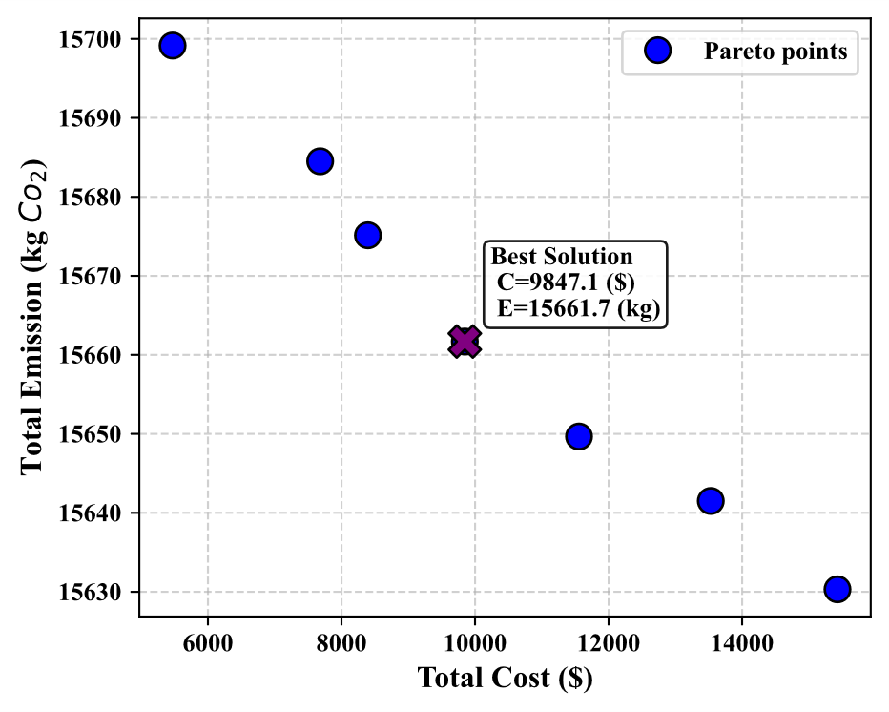
Fig 12

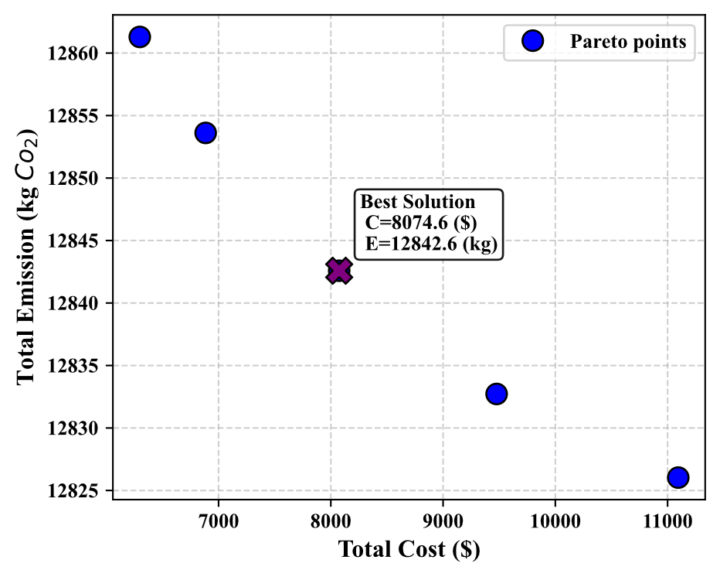
Fig 13

Comment:
• Scalability: The study uses 150 users. The authors should discuss the computational complexity of the NSGA-II algorithm as the number of users or resources increases to prove the framework's scalability for larger distribution networks.
Response:
Thank you for the comment. A scalability discussion has been added to the Methodology section, clarifying that NSGA-II runtime increases with the selected population/generation settings and, in this framework, is largely driven by repeated evaluation of candidate schedules over the 24-hour horizon across all users and modeled resources. It is stated that increasing the number of users/resources increases evaluation workload and runtime. Future work is noted for extending the framework to larger distribution networks and quantifying runtime growth.
Action:
action in methodology:
Scalability beyond the 150-user case study is discussed by noting that the computational burden of NSGA-II increases with the chosen population size and number of generations, and more critically in the present framework with the cost of evaluating each candidate schedule. For each candidate solution, objective values and feasibility checks are computed across the full 24-hour horizon and across all users and modeled, including operational constraints such as power balance and device limits. As the number of users and/or modeled resources increases, the per-candidate evaluation workload increases accordingly under fixed NSGA-II settings, resulting in higher overall runtime.
action in conclusion:
Future work will also address toward large-scale distribution networks with higher numbers of users and additional resources, where runtime growth under increasing system size is to be quantified. Scalability-oriented implementations are to be investigated, including parallel evaluation of candidate solutions and user aggregation into representative profiles, in order to maintain computational tractability for larger systems.

3. Comparative Evaluation
Comment:
• Algorithm Benchmarking: The methodology uses NSGA-II. To demonstrate the "efficiency" of the proposed framework, the results should be compared against other established MOO algorithms (e.g., MOPSO or SPEA2) or recent metaheuristics mentioned in the literature review
Response:
Thank you for your suggestion. To show the efficiency of the NSGA-II-based framework, we benchmarked the algorithm against an existing multi-objective optimizer, MOPSO, via identical experimental settings. Both algorithms were run with the same population size (50) and termination criterion (200 generations) and used the identical problem formulation, constraints, and objective functions. A convergence plot (Fig. 14) was added to show search progress, and Table 2 was added to give the best-compromise operating point and runtime for both with-DR and without-DR scenarios. The results reveal that NSGA-II provides a stronger compromise in the DR situation (NSGA-II: C = 8074.6, E = 12842.6) than MOPSO (C = 8345.5, E = 13127.4) with a comparable runtime (418 s vs. 451 s), hence confirming the efficiency claim.
Action:
The representative best solution from the Pareto set is used in the comparative analysis. Fig. 12 and Fig. 13 shows that DR improves the practical cost-emission trade-off. This is notable because DR increases performance by lowering both objectives simultaneously (without DR, C = 9847.1 and E = 15661.7; with DR, C = 8074.6 and E = 12842.6).

In measuring the success of the proposed NSGA-II solver, an analogous benchmarking of MOPSO has been conducted using the same EMS formulation and computational parameters. In this case, both algorithms are assigned a population of 50 and are set to run for 200 generations. They are also subject to the same decision-variable scope and constraints. Fig. 14 shows the convergence behaviour, and Table.2 summarizes the quantitative benchmarking data.

Table.2 illustrates that in the DR case, NSGA-II achieved a better compromise by decreasing both objectives than MOPSO (NSGA-II: C = 8074.6, E = 12842.6; MOPSO: C = 8345.5, E = 13127.4), while keeping the time spent the same. Without DR, the best solutions selected show comparable NSGA-II costs C = 9847.1; MOPSO: C = 10291.2. Yet, NSGA-II attains slightly lower emissions (15661.7 vs. 15806.3). The benchmarking confirms that NSGA-II is computationally efficient, providing reliable convergence and superior cost-emission trade-offs in the examined EMS problem.

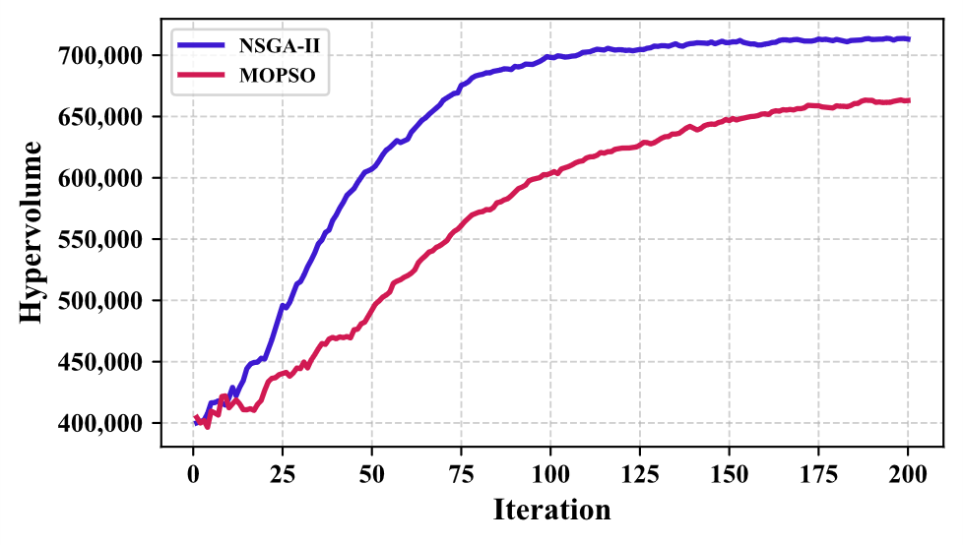
Figure 14

Table 1
Algorithm | DR | Best-compromise Cost ($) | Best-compromise Emission (kg CO₂) | Runtime (s)
NSGA-II | Without | 9847.1 | 15661.7 | 342
NSGA-II | With | 8074.6 | 12842.6 | 418
MOPSO | Without | 10291.2 | 15806.3 | 354
MOPSO | With | 8345.5 | 13127.4 | 451

Comment:
• Impact of HT: The innovation section highlights the role of the Hydrogen Turbine as dispatchable generation. However, the results (Fig. 7 and 9) do not clearly isolate the specific benefit of the HT compared to BESS alone. A sensitivity analysis on HT capacity would strengthen the paper.
Response:
We sincerely appreciate this constructive comment. To ensure that the contribution of HT (hydro turbine) is explicitly supported by quantitative evidence beyond the flexibility provided by BESS/EVs, we have added a sensitivity analysis on hydro turbine availability. In Table 2, just before conclusion. The reports the system performance under 30%, 50%, and 100% hydro turbine availability
Action:
As demonstrated in Table 2, a sensitivity analysis on hydro turbine availability (30%, 50%, and 100%) shows that system performance improves monotonically as hydro contribution increases. The total cost reduces from $10,384.26 (30%) to $8,074.60 (100%), emissions from 16,775.12 to 12,842.58 kg, and grid import from 14,151.90 to 10,899.29. This sensitivity analysis indicates increasing hydro turbine availability delivers more controlled supply, decreases dependence on grid purchases, and improves overall cost-emission performance.

Table 2. Sensitivity of system cost, emissions, and grid exchange to hydro turbine availability.
Hydro turbine | Cost ($) | Emission (kg) | Import From Grid (kW)
30% | 10384.26 | 16775.12 | 14151.90
50% | 9852.76 | 15411.67 | 13164.50
100% | 8074.60 | 12842.58 | 10899.29

4. Presentation and Formatting
Comment:
• Figure Quality and Labels: Several figures (e.g., Fig. 1 to 13) are referenced but the actual graphical data must be clearly legible, with all axes properly labeled and units provided
Response:
With sincere appreciation for the reviewer’s careful attention and constructive comment, we thoroughly reviewed and revised all figures (Figs. 1–13) and corrected the identified issues. Specifically, the legends and numeric annotations were refined, figure titles and axis units/scales were standardized and completed, and all figures were re-exported at appropriate size and high resolution to ensure clear legibility in the final manuscript.
Action:
All figures (Figs. 1–14) have been rechecked (highlighted) and revised based on respectful reviewer concern.

Comment:
• Grammar and Syntax: The manuscript contains several grammatical errors and awkward phrasing (e.g., "The move to RES outcomes promises advancements..." "HT will supply a reliable backup to heating safe...”). A thorough professional English edit is required.
Response:
With best regards and thank you for this important and constructive comment. The manuscript rechecked and revised due to enhance readability and avoid grammatical errors.
Action:
the words/sentences checked and edited with (blue-gray).

Comment:
• Citation Consistency: Ensure all references in the text (e.g., Behera et al., 2025) match the reference list exactly
Response:
With gratitude for precise and constructive comment. In order to enhance the value and consistency of the paper several references added from ”International Journal of Renewable Energy Development” journal, and also, all the recent citations have been rechecked to match with the given reference list.
Action:
All in-text citations were cross-checked against the reference list, and inconsistencies were corrected.

