Supplementary Information

Bi-directional Modulation of Electron Transfer and Capacitive Behavior in Sediment Microbial Fuel Cells by Hydrochar and Acetate

Marcelinus Christwardana^{a,b,c,*}, Yayuk Astutiª, H. Hadiyanto^{d}, Achmad Yanuar Maulana^{e,f}, K. Khoirunnisaª, Dilla Dayanti^{b,c}, Keisya Natania Nur A'intanª
ªDepartment of Chemistry, Faculty of Science and Mathematics, Diponegoro University, Indonesia 50275
^{b}Master Program of Energy, School of Postgraduate Studies, Diponegoro University, Indonesia 50241
^{c}Research Collaboration Center for Electrochemistry, BRIN - Diponegoro University, Indonesia 50275
^{d}Department of Chemical Engineering, Faculty of Engineering, Diponegoro University, Indonesia 50275
^{e}Department of Chemistry, Dong-A University, Busan 49315, South Korea
^{f}Institute of Natural Science (G-LAMP), Dong-A University, Busan 49315, South Korea

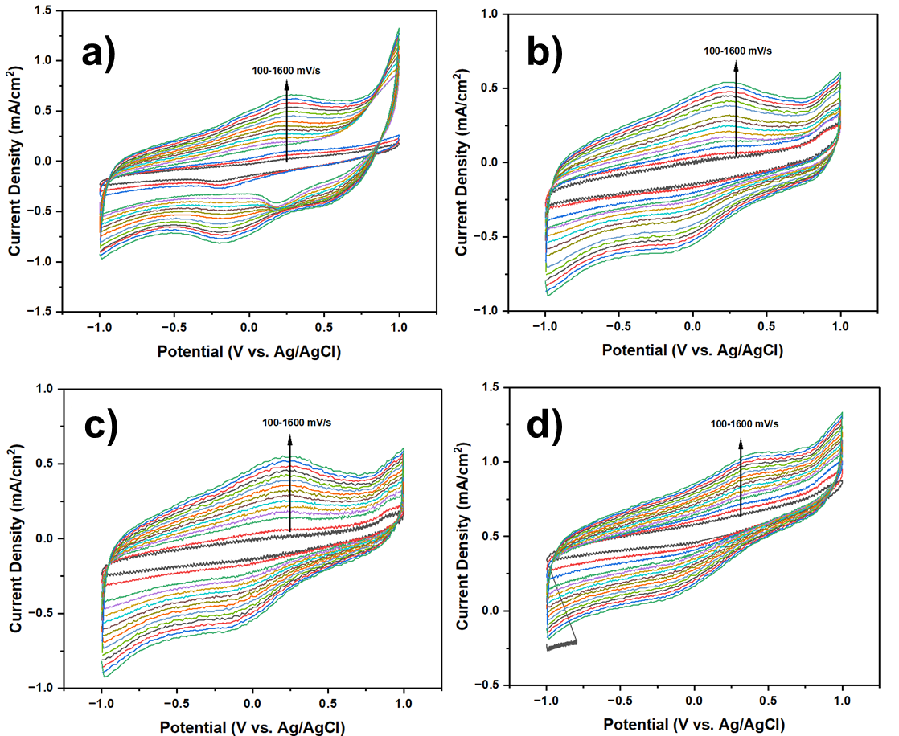
Fig S1. Cyclic Voltammetry curves of MS-MFC with MS only in anode chamber at a) day-0, b) day -21 (without acetate), c) day-21 (with acetate), and d) day-30 under various scan rate between 100 to 1600 mV/s

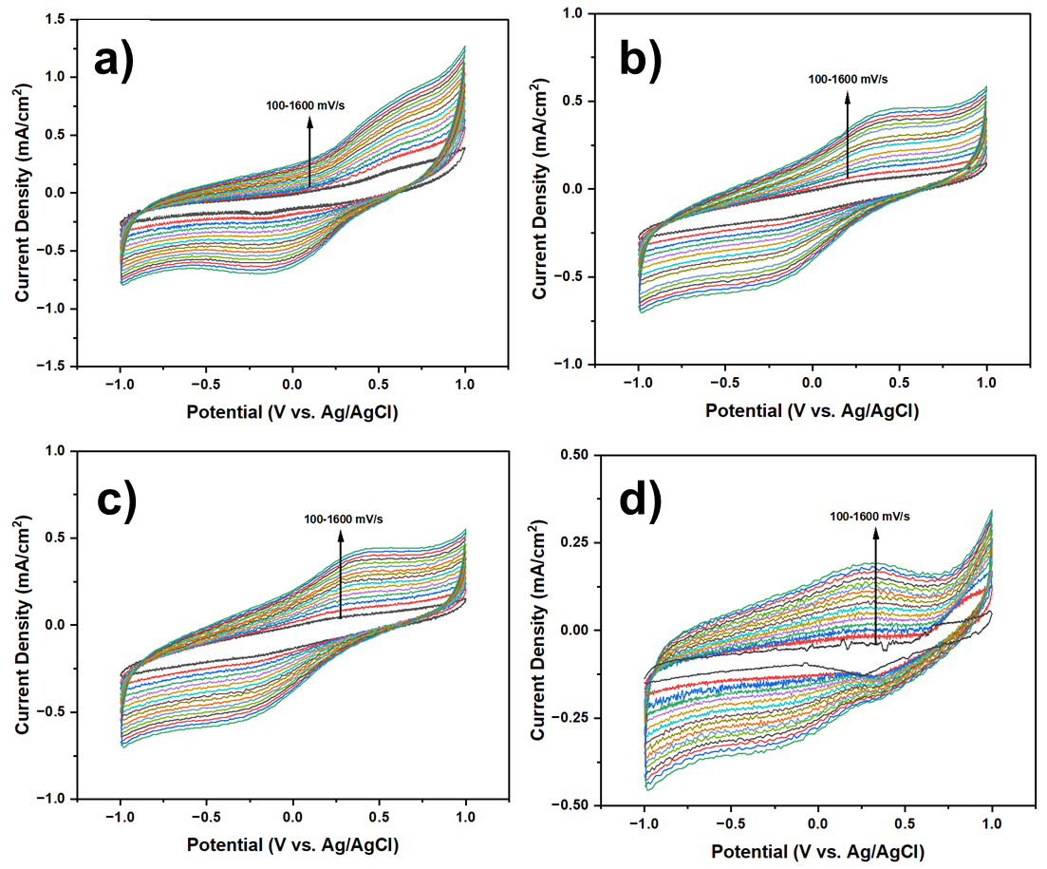
Fig S2. Cyclic Voltammetry curves of MS-MFC with MS + 5%HC in anode chamber at a) day-0, b) day -21 (without acetate), c) day-21 (with acetate), and d) day-30 under various scan rate between 100 to 1600 mV/s

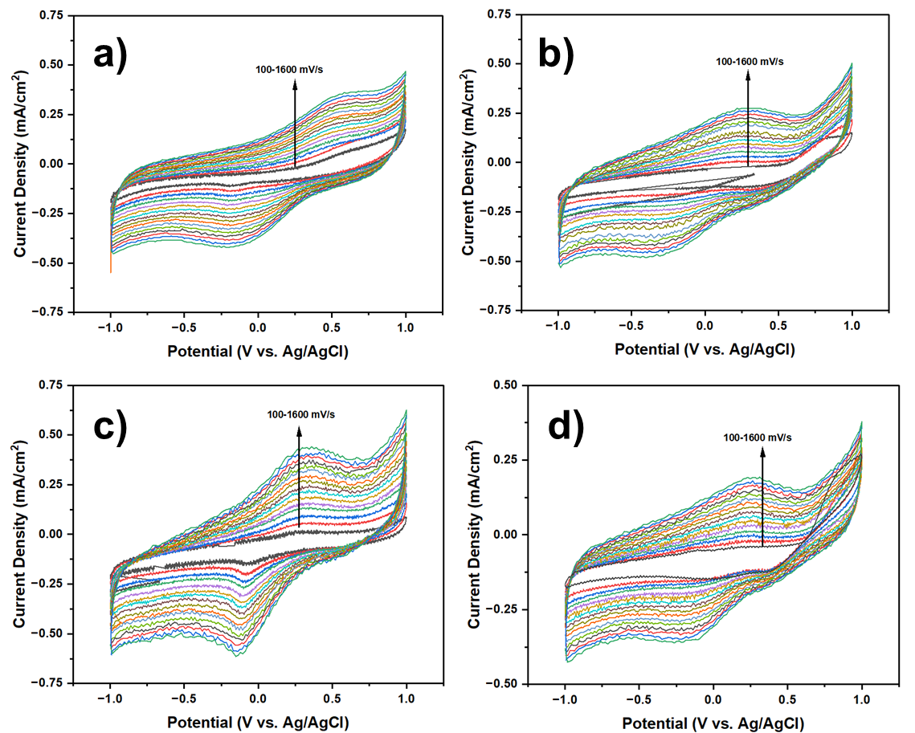
Fig S3. Cyclic Voltammetry curves of MS-MFC with MS + 10%HC in anode chamber at a) day-0, b) day -21 (without acetate), c) day-21 (with acetate), and d) day-30 under various scan rate between 100 to 1600 mV/s

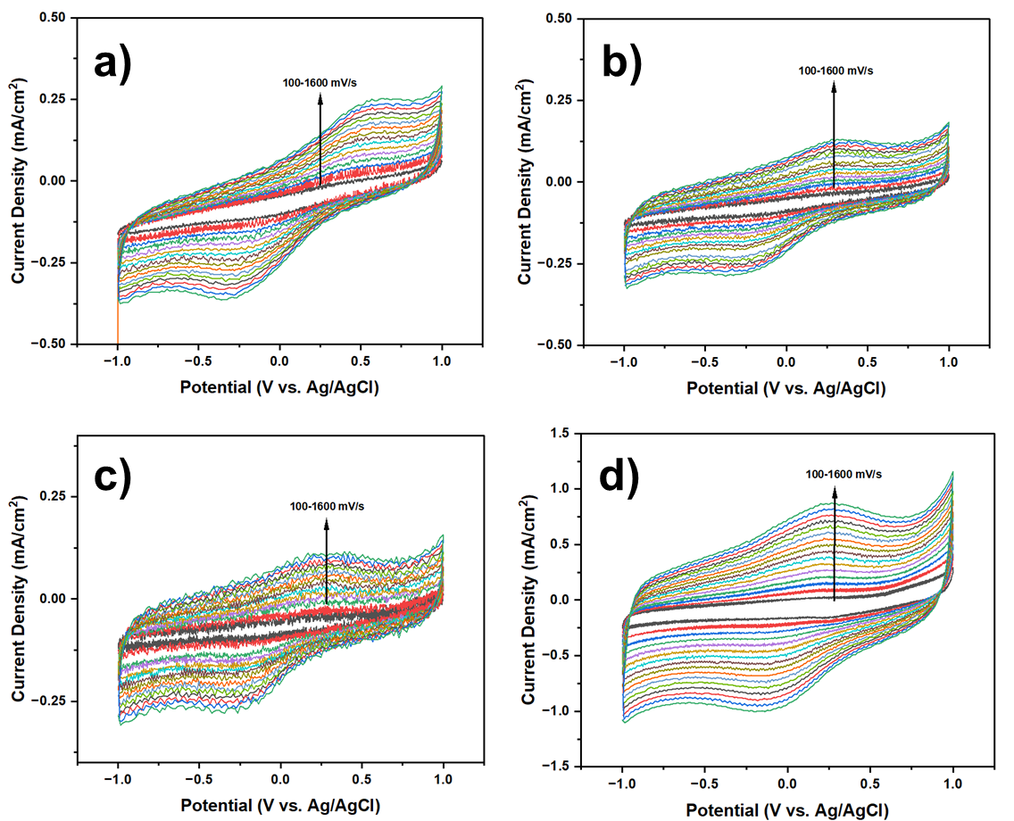
Fig S4. Cyclic Voltammetry curves of MS-MFC with MS + 15%HC in anode chamber at a) day-0, b) day -21 (without acetate), c) day-21 (with acetate), and d) day-30 under various scan rate between 100 to 1600 mV/s

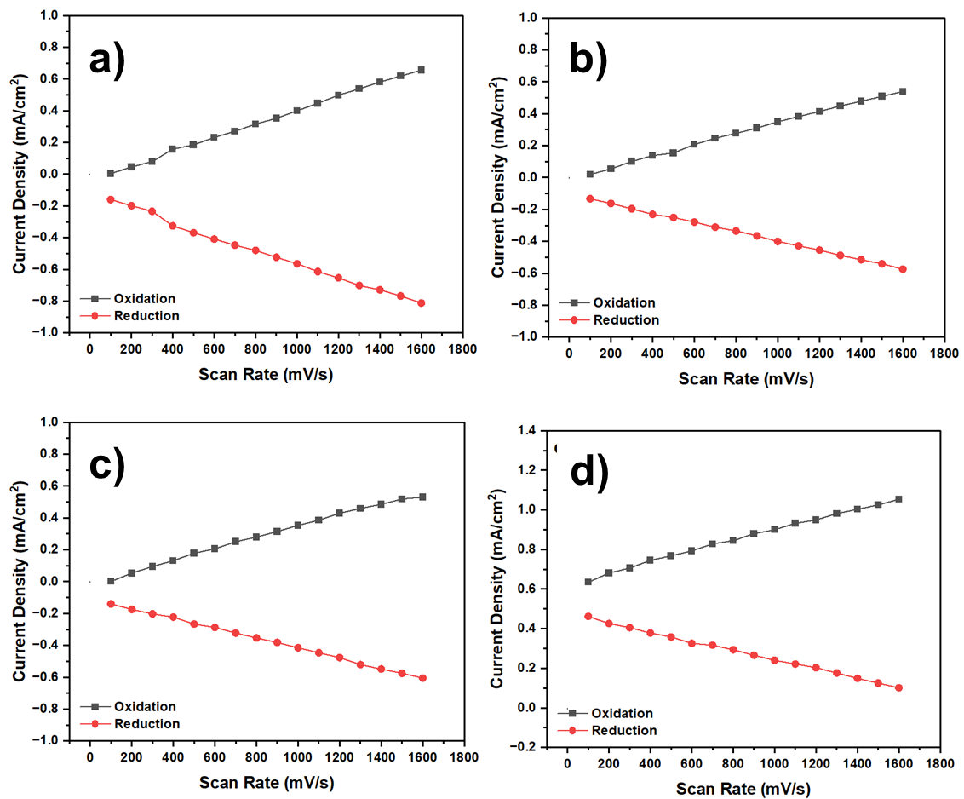
Fig S5. Correlation between scan rate and current density of MS-MFC with MS only in anode chamber at a) day-0, b) day -21 (without acetate), c) day-21 (with acetate), and d) day-30

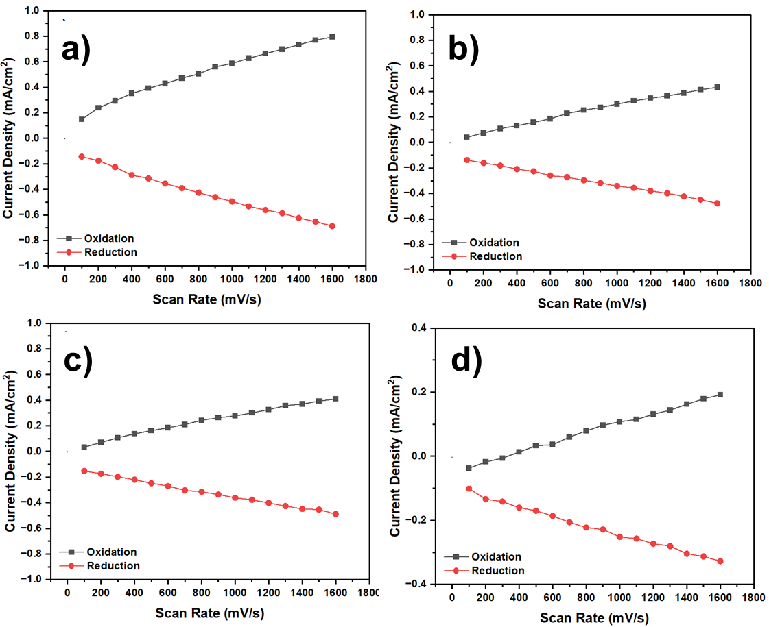
Fig S6. Correlation between scan rate and current density of MS-MFC with MS + 5%HC in anode chamber at a) day-0, b) day -21 (without acetate), c) day-21 (with acetate), and d) day-30

Fig S7. Correlation between scan rate and current density of MS-MFC with MS + 10%HC in anode chamber at a) day-0, b) day -21 (without acetate), c) day-21 (with acetate), and d) day-30

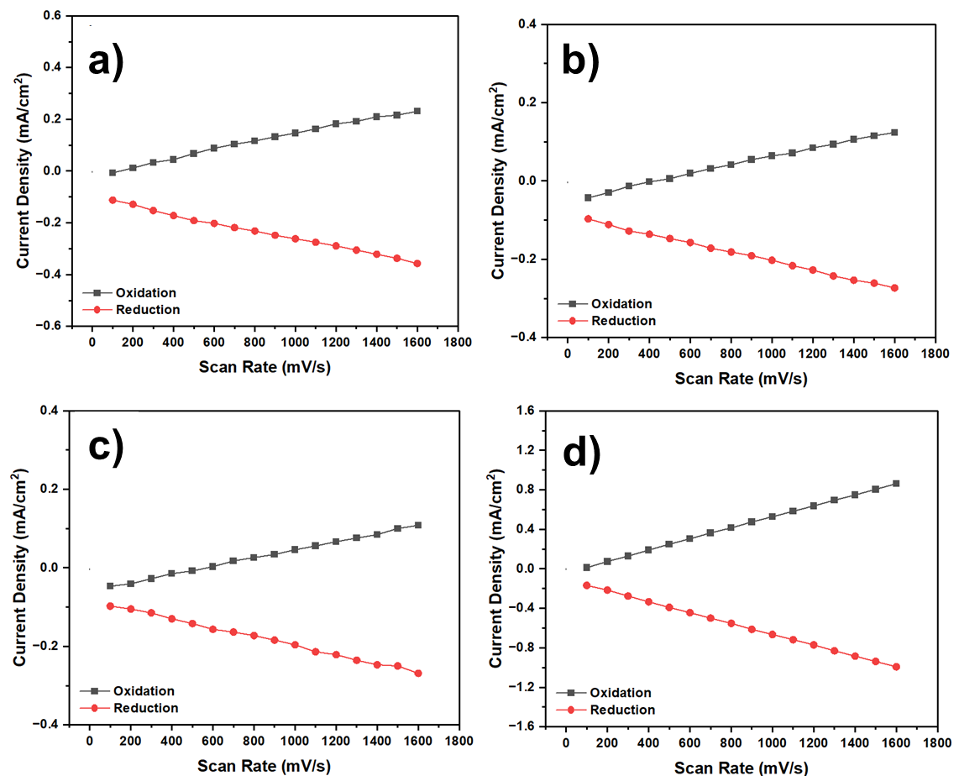
Fig S8. Correlation between scan rate and current density of MS-MFC with MS + 15%HC in anode chamber at a) day-0, b) day -21 (without acetate), c) day-21 (with acetate), and d) day-30

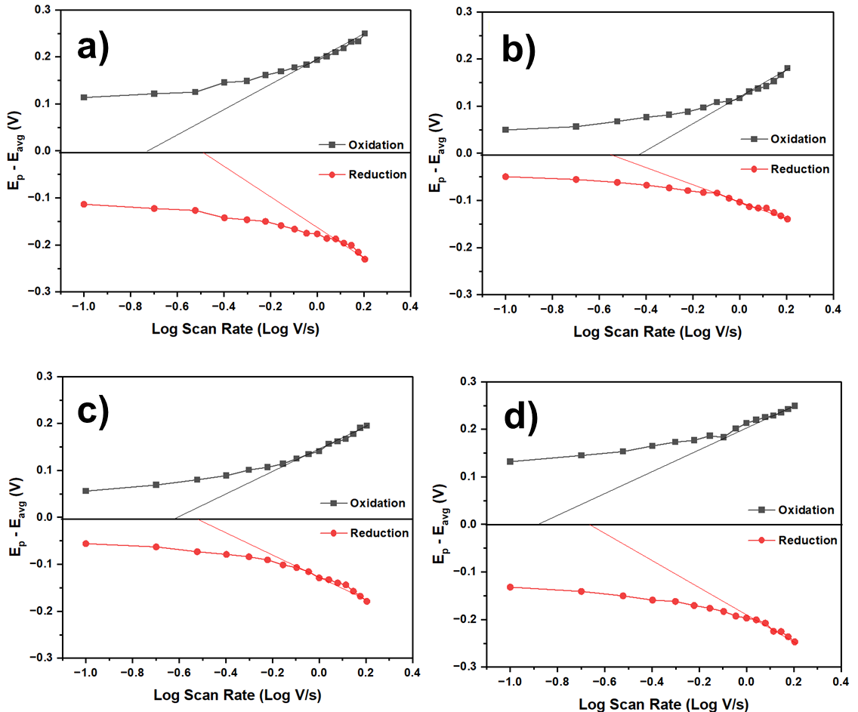
Fig S9. Laviron plot of MS-MFC with MS only in anode chamber at a) day-0, b) day -21 (without acetate), c) day-21 (with acetate), and d) day-30

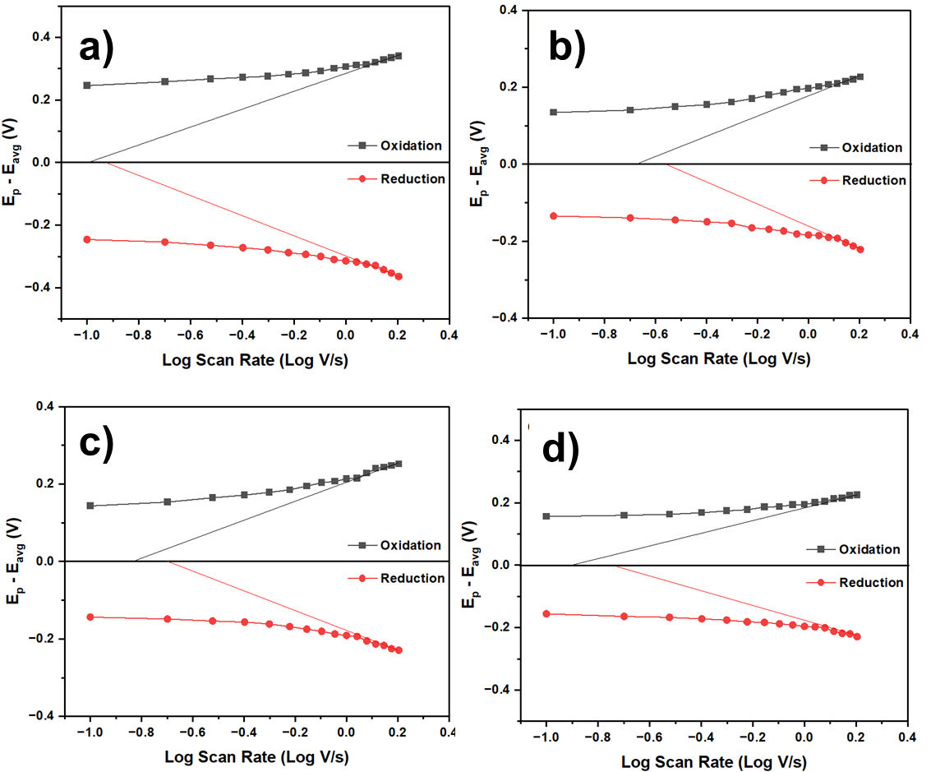
Fig S10. Laviron plot of MS-MFC with MS + 5%HC in anode chamber at a) day-0, b) day -21 (without acetate), c) day-21 (with acetate), and d) day-30

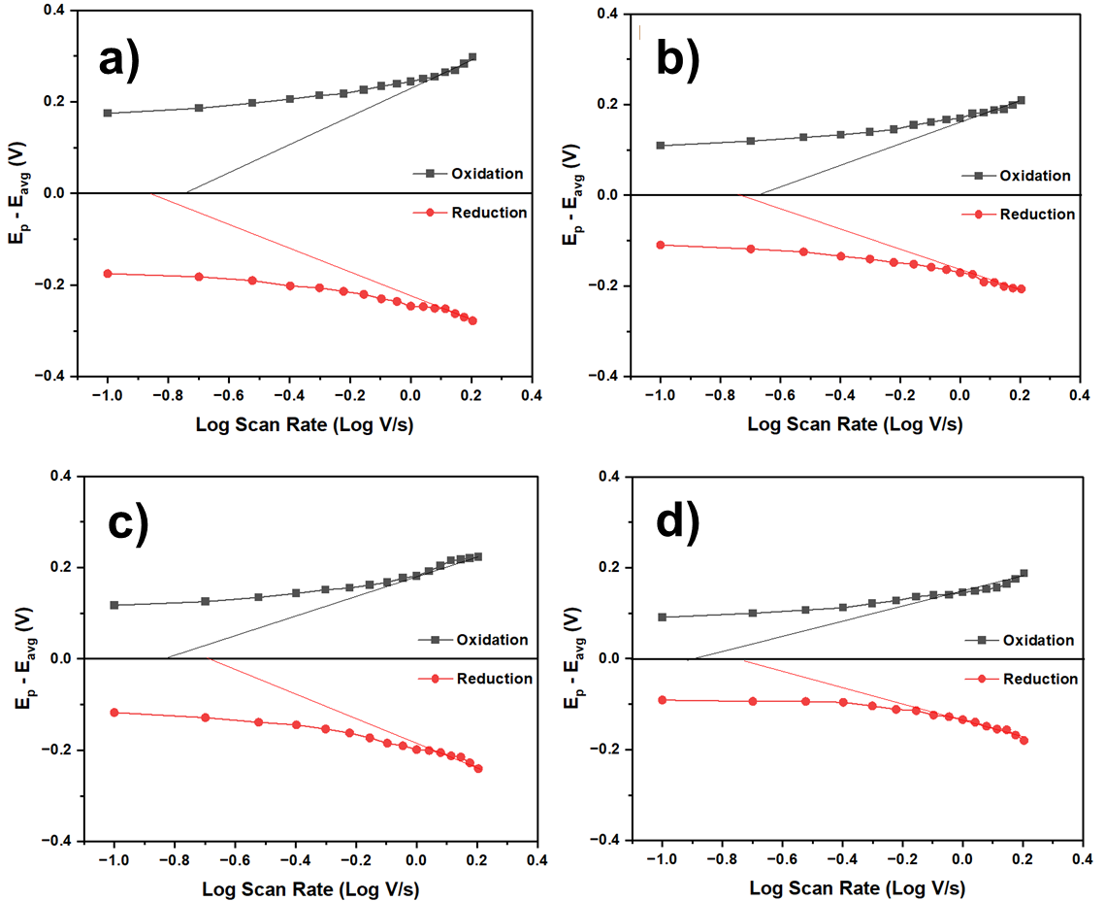
Fig S11. Laviron plot of MS-MFC with MS + 10%HC in anode chamber at a) day-0, b) day -21 (without acetate), c) day-21 (with acetate), and d) day-30

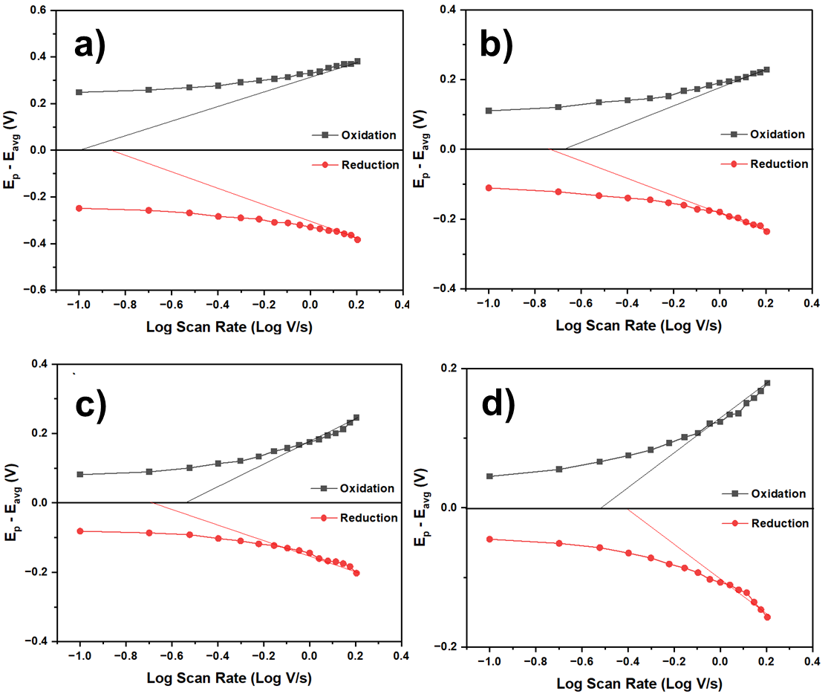
Fig S12. Laviron plot of MS-MFC with MS + 15%HC in anode chamber at a) day-0, b) day -21 (without acetate), c) day-21 (with acetate), and d) day-30

