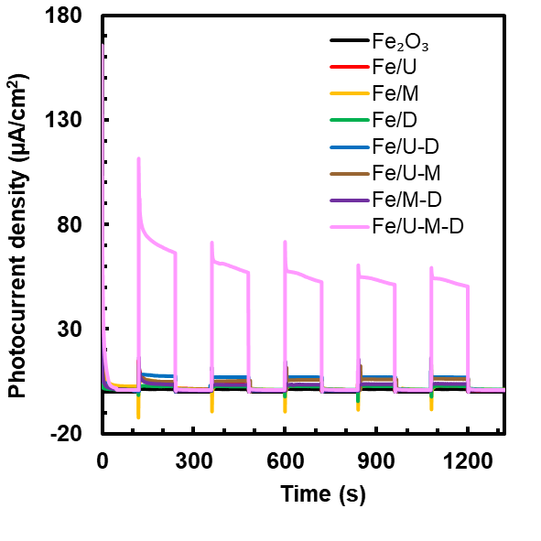
Figure S1. Chronoamperometry responses of α-Fe₂O₃ and α-Fe₂O₃/g-C₃N₄ photoanodes with various hybrid precursor compositions under intermittent light irradiation (2 min dark–2 min light cycles, repeated five times), presented in linear scale to show the actual photocurrent density profiles of all samples.

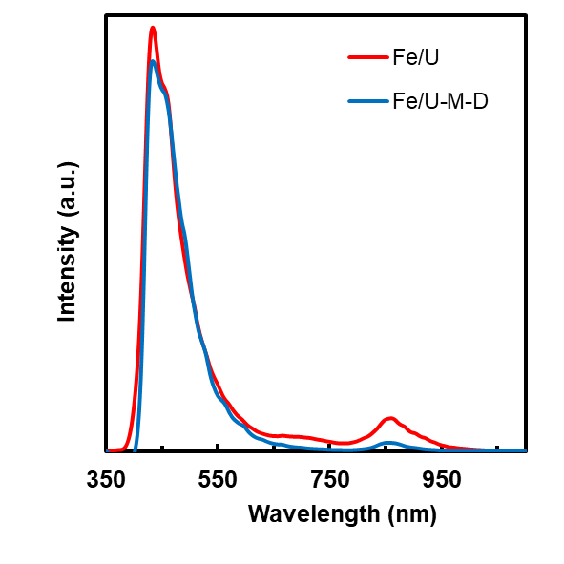
Figure S1. Photoluminescence (PL) spectra of α-Fe₂O₃/g-C₃N₄ photoanodes synthesized using single precursor (Fe/U) and hybrid precursor (Fe/U–M–D), recorded at an excitation wavelength of 325 nm, illustrating reduced emission intensity for the hybrid system, indicative of suppressed electron–hole recombination.

Table S1. g-C3N4 Crystal Size with Hybrid Precursors.
Sample | 2θ | FWHM | L (nm)
CN/D | 27.24 | 0.81 | 32.21
CN/M | 27.31 | 0.61 | 48.86
CN/U | 27.81 | 1.09 | 34.28
CN/M-D | 27.52 | 1.207 | 17.79
CN/U-M | 27.47 | 1.349 | 15.09
CN/U-D | 27.46 | 1.334 | 15.12
CN/U-M-D | 27.38 | 1.406 | 13.05

